Prof. Nicholas V.C. Polunin

Editor

Environmental Conservation

Cambridge University Press

1 Liberty Plaza, Floor 20

New York, NY 10006

USA

May 12, 2017

Dear Prof. Polunin and Associate Editors:

I am submitting the manuscript *Using a qualitative model to explore impacts of ecosystem and anthropogenic drivers upon declining marine survival in Pacific salmon* for consideration for publication in *Environmental Conservation*. The broad scope of the journal, drawing science and policy/management audiences, makes this journal an ideal forum for this paper.

The qualitative network model described within our manuscript was useful for exploring potential drivers of declines in salmon marine survival. While the topic presented here is place-specific, the approach used is broadly applicable and is one of the few analytical techniques that can incorporate biological and human dimensions information within a unified framework. Frameworks for exploring social-environmental systems are numerous, but empirical applications of these frameworks are less common, and analysis within a simulation framework—as is commonly done for ecological models—is rare. This contribution demonstrates how network models and simulations can be used together to evaluate a suite of impacts to a declining resource (Pacific salmon). For this reason, the paper will be of interest to a variety of readers exploring a range of conservation problems.

Please note that this manuscript has been internally peer-reviewed (Drs. Christopher Harvey and Isaac Kaplan, as well as by NOAA-NWFSC management) according to NOAA-Fisheries policy prior to submittal.

On behalf of my co-authors, thank you for accepting this manuscript for review.

Sincerely,

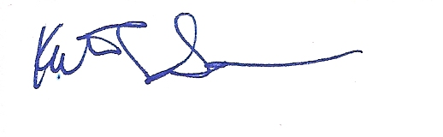

Kathryn L. Sobocinski, PhD

NOAA-Affiliate, Long Live the Kings

Fish Ecology Division

NOAA Fisheries - Northwest Fisheries Science Center

2725 Montlake Blvd. E, Seattle, WA 98112

[kathryn.sobocinski@noaa.gov](mailto:kathryn.sobocinski@noaa.gov)